**SPRINT-3**

|  |  |
| --- | --- |
| **DATE** | **12 NOVEMBER 2022** |
| **TEAM ID** | **PNT2022TMID30006** |
| **PROJECT NAME** | **NUTRITION ASSISTANT APPLICATION** |

**NUTRITION DIET CHART (VEGETARIAN)**

|  |  |  |  |  |  |  |  |
| --- | --- | --- | --- | --- | --- | --- | --- |
| **DAYS/TIMINGS** | **6.30 AM** | **8.30 AM** | **11.00 AM** | **12.30 PM** | **4.00 PM** | **6.30 PM** | **8.00 PM** |
| **MONDAY** | **Honey &cinnamon Drink (1 cup)** | **Red poha with veggies (1bowl) &sprouts (3 tbsp)** | **Mint Jeera butter Milk (1 glass)** | **Moong Dal Khichdi [1 bowl] and cucumber raita [1katori]** | **Green tea ( 1cup) & Roasted Makhana (5 tbsp)** | **Pepper milk [ 1cup]** | **Whole wheat pulka (2no) & veg curry (1 bowl) & (pumpkin soup (1 cup)** |
| **TUESDAY** | **Lemon Juice (1 cup) & Almond (5** **no's)** | **Brown rice** **idly**  **(3 n0) & sambar** | **Fruit bowl** | **Matkin** **Amit curry [1 bowl] & Tomato pepper** **Rassam [1 bowl] &millet roti [2** **no's]** | **Tea without sugar (1 cup) & chana Sundal (5 tbsp)** | **Turmeric milk** | **Pumpkin dal soup with Oats (1bowl) & sauteed coloured pepper (1bowl)** |
| **WEDNESDAY** | **Coconut water (1 cup)** | **Oats with milk (1bowl) &Moong Sprouts raw (3 tbsp) & 1 Fruit** | **Blanched vegetable juice (1 glass)** | **Multigrain Roti [2 no] &** **Lalik Dal [ 1bowl]**  **& Butte r milk [1 glass]** | **Lime juice (salty) [1 glass] &**  **Groundnut Tikki (50 gm)** | **Cucumber slices with hummus** | **Whole wheat pulka (1no) & capsicum curry (1 bowl) & Dal garlic soup (1 bowl)** |
| **THURSDAY** | **Pomegranate juice (1 cup)** | **Mixed Veg Brown bread Sandwich (2 slice) & Sprouts (3 tbsp)** | **Tender coconut water (1 glass)** | **Rice (1 bowl) &Dal [1 bowl] &Tomato garlic Rassam [1 bowl]** | **Herbal tea (1 cup) & Roasted** **Behl (50 gm)** | **Herbal cottage cheese & cinnamon water** | **Boiled sweet potato chaat & Mushroom soup (1 bowl)** |
| **FRIDAY** | **Ginger Tulsi Tea (1 cup) & Walnuts (3** **no's)** | **Chola Paratha (1 no) &Chutney (3 tbsp)** | **Watermelon (1 bowl)** | **Stuffed multigrain paratha [2 no] & cucumber raita (1** **Katori)** | **Boiled peanuts (50 gm) &** **green Tea (1 cup)** | **Green herb juice & nuts** | **Broken wheat h** **kichadi (1bowl) & chutney (3 tbsp)** |
| **SATURDAY** | **Cucumber Carrot Juice (1 glass)** | **Besan** **Chila with veggies stuffed & chutney (3 tbsp)** | **Nulty fruit salad (1 bowl)** | **Whole wheat** **pulka (2 no) & chola curry (1 bowl)** | **Green tea (1 cup) & Bhujia (3tbsp)** | **Baby carrots with blue cheese & cinnamon milk** | **Panner wrap (1 no) & sauteed mixed vegetable salad ( 1bowl)** |
| **SUNDAY** | **Tulsi tea (1cup) &Pumpkin seeds (3** **no's)** | **Brown rice Dosa (2 no) & sambar (1bowl)** | **Ragi Buttermilk porridge [1 bowl]** | **Brown rice (½ bowl) & vegetable salad (1bowl) & pump kin dal (½ bowl)** | **Ginger tea (1 cup) & Boiled green peas chat (3 tbsp)** | **Oatmeal & seed mix** | **Jowar** **pulka (2 no) & green peas curry (1bowl) & moringa leaves tomato soup (1 bowl)** |

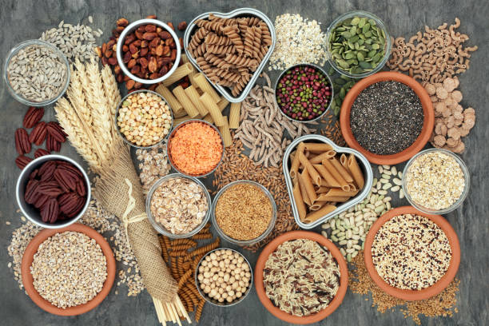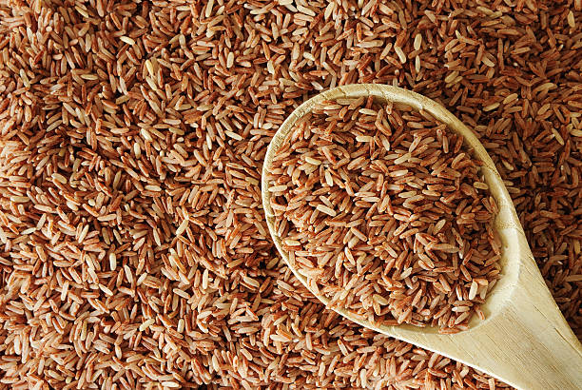

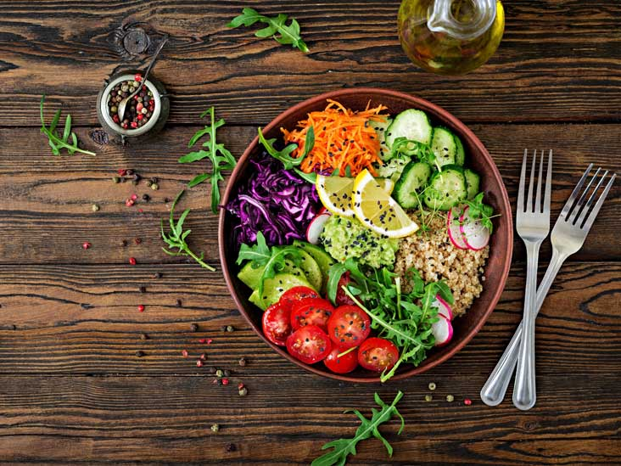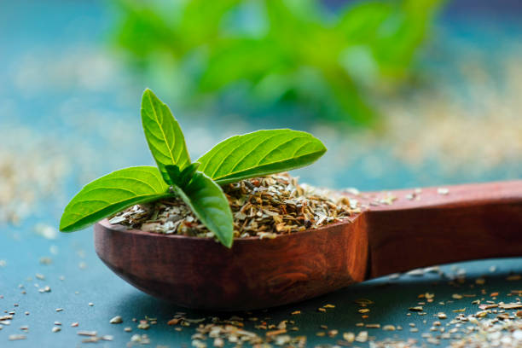

**NUTRITION DIET CHART (NON-VEGETARIAN)**

|  |  |  |  |  |  |  |  |
| --- | --- | --- | --- | --- | --- | --- | --- |
| **DAYS/TIMING** | **6.30 AM** | **8.30 AM** | **11.00 AM** | **12.30 PM** | **4.00 PM** | **6.30 PM** | **8.00 PM** |
| **MONDAY** | **1 Glass of carrot juice** | **2 Brown rice idlys & sambar** | **Boiled Legumes** | **1 Roti with bowl of chicken curry** | **1 cup of watermelon** | **1 large orange** | **Mixed vegetable curry & 2 chapatis** |
| **TUESDAY** | **1 Glass of milk** | **2 Boiled egg & skimmed milk** | **Ragi Porridge** | **Whole Grain roti & fish curry** | **1 cup of cucumber rice** | **1 serving of seasonal fruit** | **Khichdi with oats & dry fruits (small bowl)** |
| **WEDNESDAY** | **½ cup sliced carrots and glass of lemon juice** | **Multigrain roti with fixed vegetable curry** | **Masala peanuts** | **Vegetable salad with chicken chest** | **1 cup of pear** | **Oatmeal & seed mix** | **Mutton soup & prawn curry** |
| **THURSDAY** | **1 glass of cucumber water** | **EGG whites & a glass of milk** | **Millet cookies** | **Fish curry with mixed vegetable salad & brown rice** | **1 cup of boiled and green peas** | **Cucumber slices with hummus** | **Boiled chicken with oats and apple** |
| **FRIDAY** | **Black coffee without sugar** | **Green vegetable salad & curd** | **Carrot sticks and hummus** | **Cards with roasted chicken chest** | **1 cup of spinach** | **Baby carrots with blue cheese & cinnamon milk** | **Tocred milk** |
| **SATURDAY** | **Bottle gourd juice** | **Chanadal pancake with mixed veggies** | **Green gram sprouts** | **TOFO & Salmon curry with 2chapathis** | **1 cup of buttermilk** | **1 bowl of mixed vegetables** | **Orange & Buttermilk** |
| **SUNDAY** | **1 Glass of lemon water** | **Oatmeal with fresh berries** | **Wheat rusk** | **2 Parottas with chicken curry** | **1 cup of boiled egg** | **1 large mosambi** | **Fish with spinach salad** |

